Pailton Parish Council
c/o Holly Barn, Main Street, Harborough Magna, Rugby CV23 0HS
tel:01788 833594 email: clerk@pailtonparishcouncil.org.uk

Mr John Legg
The Planning Inspectorate, N/A
Temple Quay House
2 The Square
Bristol, BS1 6 PN

[to be] Sent via email: john.legg@planninginspectorate.gov.uk

Dear Mr Legg

APPEAL REFERENCE: APP/E3715/W/22/3306652
LAND REAR OF CROSS IN HAND FARM, LUTTERWORTH ROAD, MONKS KIRBY

On behalf of Pailton Parish Council I am writing to reiterate our firm view that this large development of 11.71 hectares, should not be given consent on appeal. We have previously written to Rugby Borough Council expressing our views which have been informed by three factors: planning matters; need or demand and finally, the impact that this development, should it receive consent, would have on our small village.
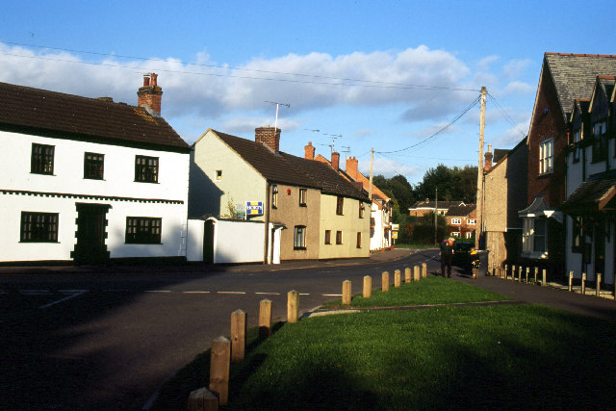 1,

Planning Matters
- This application is contrary to Rugby Borough Council’s approved Local Plan 2011-2031 – particularly Policy ED3, nor does it meet the exceptions within Policy ED4.
- This proposal would have a hugely detrimental impact on the local landscape and environment, in terms of its layout, scale, light pollution, noise and increased traffic flows through the neighbouring small villages.
- Leicestershire County Council also acknowledge it would have a significant impact on air pollution, which is already significant along the A5.
- Rugby Borough Council provided significant information on designation of this land and concluded that ‘the irreversible loss of this land as a result of this development would be significant to agriculture in general’. It cannot be considered a sustainable or acceptable development.

Need or Demand
- There simply is no need for an additional 378 HGV parking spaces in this location.
Magna Park has more than sufficient HGV parking and has planning consent for further spaces to keep pace with its own developments. Almost immediately opposite the site planning is well underway for a similar service station that is sustainable within its warehouse setting
- Overnight truck stop accommodation is adequately provided on a number of sites within a short distance – all of which the applicant conveniently ignores in his narrative to support his application.
- Nor is there any need on what has been until now agricultural land for a creche, a convenience store, coffee shop or biomass plant.
- No journey to this proposed development would be by foot – and as the Lutterworth Road, has no lighting nor footways it is extremely likely that every single journey would be by motorised vehicles. It cannot be considered a sustainable or acceptable development.
Impact upon Pailton
Our comments in this area have similar resonance for all of the small Revel villages but our comments below relate specifically to Pailton.
- Pailton is a small historic village – with around 250 homes and an electoral roll of 404 people. It has three through road that meet at the Village War Memorial: Lutterworth Road, Rugby Road and Coventry Road. They are all ‘B’ class roads and many of the homes have direct frontage onto the road. For some including the beautiful Grade II Listed Pailton Hall (image 2), the distance between road surface and house walls is less than two metres, while other homes have less than 1m between the road surface and their frontages (images 1 and 3).

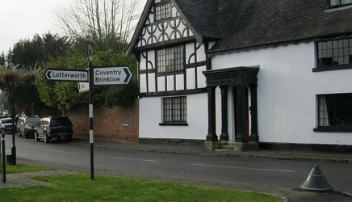2.

- The access to this proposed site is directly off the Lutterworth Road that leads straight into the centre of our village, where roads were never intended to support anything other than local traffic. The White Lion coaching inn, which the Parish Council is restoring is testament to its importance for horse and carriage – not for streams of HGVs and smaller commercial vans

- The effect of this traffic is quite physically ‘felt’ in many homes. In addition, the noise of vehicles at night disturbs residents’ sleep as multi axle vehicles clatter and shake their way through the village.
- Over the past fifteen years, with the development of Magna Park and other large distribution warehouses in and around the Rugby area, HGVs and commercial transport are increasingly using the village roads as a short cut to avoid the A5, the extremely busy A426 and part of the M6.
- We know that should the HGV facility be built it would provide more reasons for drivers of HGVs and vans to come off the major roads and take short cuts through Pailton and other villages, as shown image 3 below. These vehicles dwarf and intimidate the cottages either side of the road.

3

- Recently a Community Speed Watch initiative was established in our village. To date six sessions have been conducted. Each session was carried out for approximately one hour at the following times:
- 10.27 – 11.46 Lutterworth Road
- 17.47 – 18.47 Lutterworth Road
- 07.26 – 08.30 Lutterworth Road
- 07.33 – 08.33 Coventry Road
- 07.36 - 08.33 Coventry Road
- 17.24 - 18.16 Lutterworth Road

Only traffic coming into the Village is monitored and recorded so the total volume of traffic passing in and out of the Village at these times is much higher and in some cases might even be double. The results are:

  - An average of 150 vehicles were recorded coming into the Village across all 6 sessions
  - During the period 7.30 - 8.30 am, an average of 196 vehicles were recorded across both roads
  - For Coventry Road at the same time period this average increased to 226 vehicles
  - During the period 17.30 - 18.30 an average of 120 vehicles were recorded entering the Village via Lutterworth Road

This data is very significant in the context of number of households and the size of our village. We do not have any schools, shops or business that might generate traffic and therefore most of this traffic is likely to be only passing through our Village.

In conclusion we firmly support Rugby’s view that the cumulative impact arising from the proposed development due to its scale, massing and visual appearance would have an adverse impact upon the character and appearance of the surrounding area. It is not a sustainable development and would inevitably increase traffic flows in Pailton and harm the quality of life for our community.

Yours sincerely

Leona J Bendall
Clerk and Responsible Financial Officer to Pailton Parish Council

