Pailton Parish Council
Clerk & Responsible Financial Officer: Leona Bendall
Holly Barn, Main Street, Harborough Magna, Rugby, CV23 0HS.
T.01788 833594 clerk@pailtonparishcouncil.org.uk
12 June 2023
Attention Sam Green
Planning officer, Rugby Borough Council by email
Dear Mr Green
Application Number – R23 0310 – which is the resubmission of R20 0259 for the development of Land to the Rear of Cross in Hand Farm, Lutterworth Road, Monks Kirby
On behalf of Pailton Parish Council I am writing once again to reiterate our firm view that this large development of 11.71 hectares, should not be given consent.
- The applicant has not submitted any mitigating circumstances nor adjustments that would make this application acceptable to the Pailton Community.
- We have previously written to Rugby Borough Council and the Appeals Inspectorate expressing our views which have been informed by three factors: planning matters; need or demand and finally, the impact that this development, should it receive consent, would have on our small village.
Recent Appeal against the proposal
The Inspector’s decision on the previous submission was damming and supports all of the points we wish to make. In particular we quote these comments
‘The lorry parking would be readily seen and experienced along the Lutterworth Road, at short range, particularly as the ground slopes less steeply in the immediate vicinity of Lutterworth Road. This would change a countryside character to one dominated by intensive lorry parking: the texture, colour and presence of the lorries would be fundamentally different to the current agricultural fields.’
The inspector also noted that the effect on the proposed landscape would take more than 15 years to mitigate.
Planning Matters
- This application is contrary to Rugby Borough Council’s approved Local Plan 2011- 2031 – particularly Policy ED3, nor does it meet the exceptions within Policy ED4 and the recent appeal hearing found that Rugby’s plans in this respect were competent and current.

• Rugby Borough Council has previously provided significant information on designation of this land and concluded that ‘the irreversible loss of this land as a result of this development would be significant to agriculture in general’. It cannot be considered a sustainable or acceptable development.
Need or Demand
- There simply is no need for an additional 293 (revised number submitted to the appeal) HGV parking spaces in this location. Magna Park has more than sufficient HGV parking and has planning consent for further spaces to keep pace with its own developments. Almost immediately opposite the site consent has been given for a similar service station that is sustainable within its warehouse setting
- Overnight truck stop accommodation is adequately provided on a number of sites within a short distance – all of which the applicant conveniently ignores in his narrative to support his application.
- Nor is there any need on what has been until now agricultural land for a creche, a convenience store, coffee shop or biomass plant.
- No journey to this proposed development would be by foot – and as the Lutterworth Road, has no lighting nor footways it is extremely likely that every single journey would be by motorised vehicles. It cannot be considered a sustainable or acceptable development.
- All of these points were articulated in the Planning Inspector’s decision to refuse the Appeal – yes he conceded may be some need but not on the scale proposed and not in this location.
Impact upon Pailton
Our comments in this area have similar resonance for all of the small Revel villages but our comments below relate specifically to Pailton.
- Pailton is a small historic village – with around 250 homes and an electoral roll of 404 people. It has three through roads that meet at the Village War Memorial: Lutterworth Road, Rugby Road and Coventry Road. They are all ‘B’ class roads and many of the homes have direct frontage onto the road. For some including the beautiful Grade II Listed Pailton Hall (below), the distance between road surface and house walls is less than two metres, while other homes have less than 1m between the road surface and their frontages (page 1).
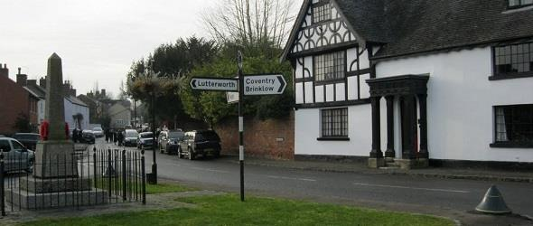

- Our village and its roads were never intended to support anything other local traffic. The White Lion coaching inn, which the Parish Council is restoring is testament to its importance for horse and carriage – not for streams of HGVs and smaller commercial vans
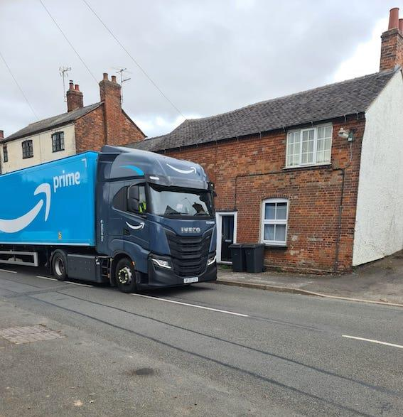
- The effect of this traffic is quite physically ‘felt’ in many homes. In addition, the noise of vehicles at night disturbs residents’ sleep as multi axle vehicles clatter and shake their way through the village.
- Over the past fifteen years, with the development of Magna Park and other large distribution warehouses in and around the Rugby area, HGVs and commercial transport are increasingly using the village roads as a short cut to avoid the A5, the extremely busy A426 and part of the M6.
- We know that should the HGV facility be built it would provide more reasons for drivers of HGVs and vans to come off the major roads and take short cuts through Pailton and other villages, as shown.
- While the Inspector noted that there was no ‘substantive evidence’ to support claims that more HGVs will use our small village roads to reach the park, we have ample anecdotal evidence and a Community Speed Watch initiative established in our village is now collecting significant data to support this.
- However, we would add that the HGVs photographs included in our response are vehicles that are contractually obliged under their lease and planning consents to use ‘approved transport routes’ that avoid our small villages. How on earth would we fare with casual visitors who would use our village whenever there was the slightest delay on the M1, M6 or A5?
- The recent photographs overleaf are indicative of the impact that HGVs have on our village : the first image shows the damage to a legally and safely parked car which was crushed by an HGV, while the second image shows that the HGV was inches away from hitting the historic Pailton Hall.
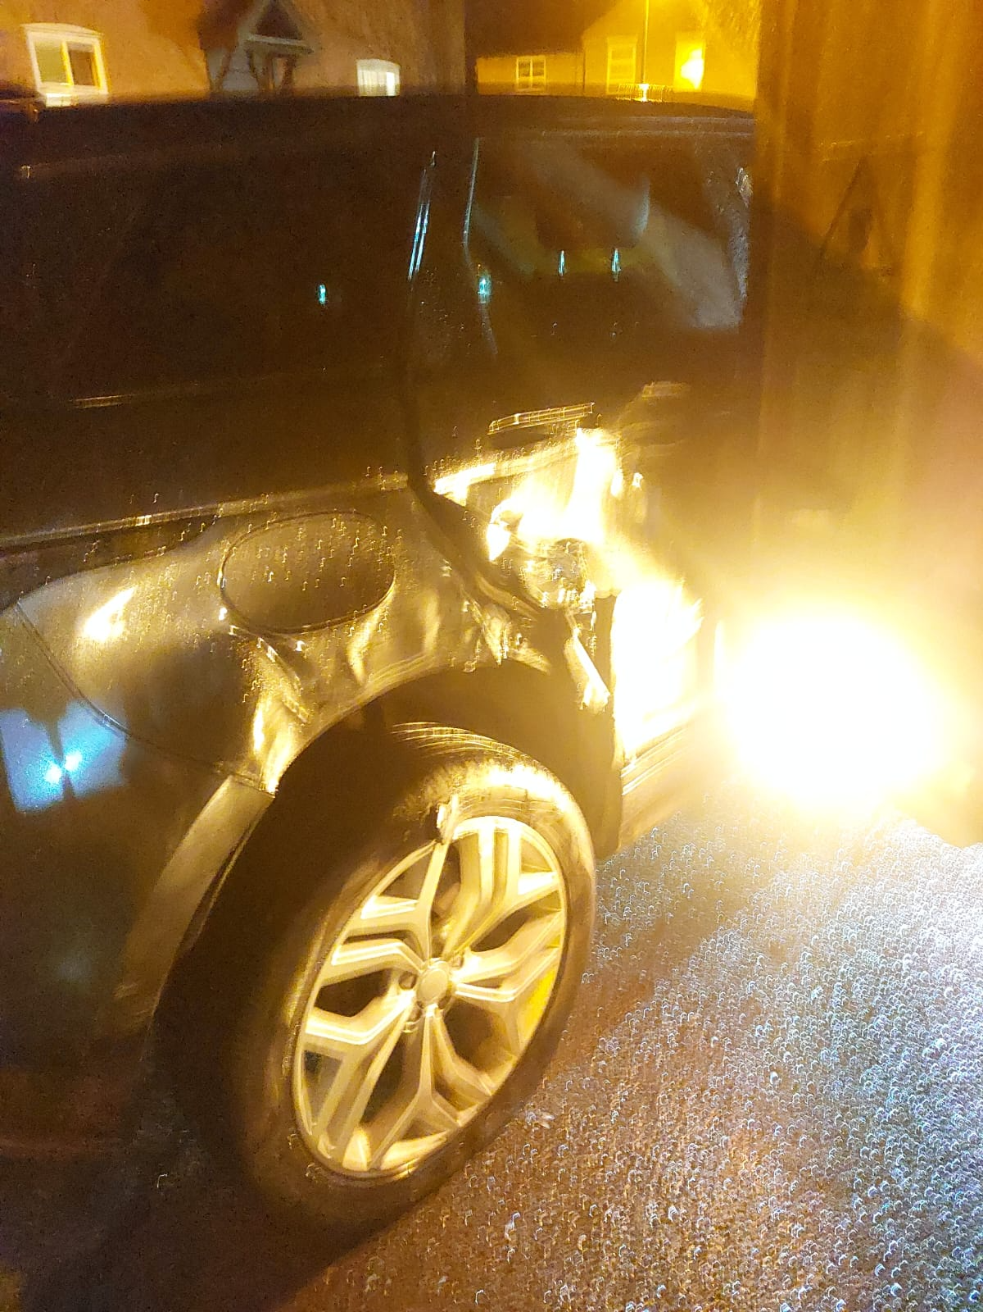

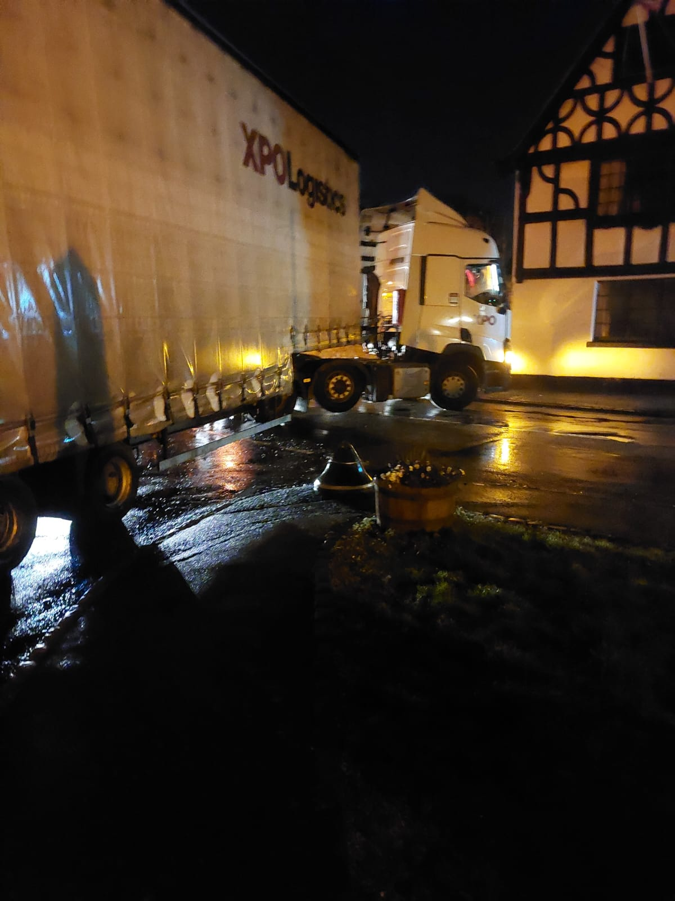

In conclusion we firmly support the Planning Inspector’s view, which is consistent with the planning decisions from Rugby Borough Council that the cumulative impact arising from the proposed development due to its scale, massing and visual appearance would have an adverse impact upon the character and appearance of the surrounding area.
It is not a sustainable development and would inevitably increase traffic flows in Pailton and harm the quality of life for our community.
Yours sincerely

Leona J Bendall
Clerk and Responsible Financial Officer to Pailton Parish Council

