Save the White Lion – Activity Statement
Development Phase – Consultations
Throughout the Development Phase, careful consideration has been given to the planning of the Activity Statement. The Activity Statement has been written by the PWLWG, with the assistance of the Project Managers, to ensure that the activities and events reflect both the needs of the community and the unique history of Pailton and the White Lion.
The Conservation Management Plan and research into the White Lion and Pailton have informed the plans, highlighting the priorities in terms of heritage stories to be told:
- the significant changes to the village as a result of the turnpike road
- the history of social activities at the White Lion, including pub game leagues
- the contribution of the Oddfellows Society to the village
- stories from villagers themselves, both past and present
These stories are reflected in the final Activity Statement.

Consultations with the community have been regularly held, both formally and informally, with the PWLWG gauging the interest from villagers in volunteering and participating in activities. In addition to countless conversations with villagers throughout the Development Phase, to make sure that plans are on track, local stakeholders were invited to take part in a dot poll. The results are summarised as follows:
This data is taken from the autumn Community Consultation event, held on Thursday 18th October. Figures are shown as a percentage of attendees.
Consultations were also undertaken with potential partners and providers, including:
- Postal Museum
- Pub History Society
- Oddfellows Society
- Re-Engage
- Pailton Parish Hall
- Pailton Pottery
- Carters Steam Fair & Signwriters; in relation to creative signwriting and calligraphy for quotes for the pub interiors
- Artworks Conservation; for advice about producing facsimiles of important historic documents
- Several members of the PWLWG also undertook training with the Oral History Society.
These consultations have assisted with planning and pricing, and in some cases will develop into more significant partnerships at Delivery Phase.

Development Phase – Pilot Activities
During the Development Phase, the PWLWG have been running a series of events. These events have been multi-purpose: to fundraise; to keep villagers engaged; and to test out the concepts of some of the activities proposed for the Delivery Phase.
Activity | Related Delivery Phase Activity | Intended Outcome | Measures of success | Evaluation
Pub Quiz  Monthly pub quiz nights held in the village hall. The hope is that these quiz nights will move to the White Lion once it reopens. |  | Fundraising | April 2022 - 40 people  May - 41 people  June - 38 people  July - 32 people  August - 32 people  Sept - 35 people  Oct - 44 people  Nov - 19 people  Dec - 38 people  May 2023 - 27 people  June - 52 people  August - 48 people  September - 54 people  October - 35 people  In total, these quiz nights have raised £2,586. | The attendance numbers demonstrate that there is a strong desire amongst villagers to attend events in a pub-type setting. It also shows that people are happy to spend money to join in with pub activities. These attendees are likely to form the ’regulars’ at the White Lion once it opens again.  The quiz nights will continue between phases of the project.
 |  | Test interest in attending pub-type events
 |  | Keep villagers engaged
Garden Party  Garden Party held at nearby Pailton Hall each summer. |  | Fundraising | 2021 - 66 attendees - £1,075 raised  2022 – 47 attendees - £1,015 raised  2023 - 52 attendees -£1315 raised | The Garden Party has raised significant sums of money each year, which has contributed towards project funds. It has also become a new annual tradition for the village, with newcomers to the villagers appreciating the opportunity to be part of village life and meet new people.
 |  | Keep villagers engaged
Pailton Fete  The PWLWG are running the bar for the village fete, and will receive 50% of the profit from the bar takings. |  | Fundraising | 503 adults attended plus many children  Negotiated keeping 50% of profits, so raised £291 | Normally the fete raises money for the church and the village, so the decision to allow the PWLWG to keep some of the profits was an endorsement and showed the village support for the project.  The PWLWG had a stall next to the bar with the plans of the pub for people to come and discuss them with us, as well a questionnaire for people to complete. People from all local villages as well as from Rugby and Coventry stopped to discuss the project. Many people from further afield were unaware of the plans, and excited to hear about them, so the stall was a fantastic way to raise awareness and garner support from those outside the village.
 |  | Test viability of a bar in the village
Pub Games Night  Held at village hall, a number of traditional pub games were offered; skittles, hookey, and devil among the tailors. | Traditional pub game tournaments | Fundraising | Initial event - 26 people attended, which was the capacity of the hall with that layout.  The event raised £286.  Joint afternoon tea and pub games event - 61 people attended across the two events.  The event raised £1,056. | The event was incredibly popular. However, the size limitations of the village hall meant that capacity was quite limited; this was because the games took up a lot of room, when all out at once for a one-off event. It has highlighted that having only one game running at a time, e.g. a skittles tournament, allows more room for attendees and therefore more income. Questions of size of game and flexibility, e.g. convertible tables, will be taken to the Design Team.  Following the initial Pub Games Night, a similar outdoor event was held during the summer, and was positively received and well attended. This additional event combined an afternoon tea during the day, and a pub games evening later the same day. Special joint tickets were sold, offering a discount price for those who attended both.
 |  | Test interest in attending pub-type events
 |  | Keep villagers engaged
Call out for memories and artefacts  The PWLWG have asked locals for any artefacts they may have that relate to the White Lion. The artefacts shared have included Oddfellow Society related items, and photographs of the pub. It has also provided opportunity for villagers to share memories of the pub when it was open. | History of White Lion display | Establish scale of artefacts etc. available to future displays | A range of artefacts and photographs from villagers.  Memories as well as objects shared. | The call out has revealed a variety of artefacts and photographs. It has demonstrated that there are still people with links to the Oddfellow Society, which helps not only with the History of White Lion display but also with the planned lectures / workshops.  One such photograph is that which belongs to the Chair of Pailton Parish Council, whose family have lived in Pailton for generations. He has shared a photograph of his Grandfather, who was the postman for the village, so would have surely used the Post Office within the White Lion. (Photograph shown below)  The photographs and memories shared have also factored in to Design Team discussions and decisions; e.g. villagers sharing past attempts to plant a garden at the front of the building.
 |  | Keep villagers engaged
Oral History  A handful of Oral History interviews will be conducted with villagers at Development Phase, to pilot the concept, but also to capture memories from a handful of residents who may not be available by the Delivery Phase. | Memory Sharing Hubs: Oral History | Test Oral History project concept | Two volunteers trained.
 |  | Capture interviews with vulnerable local residents

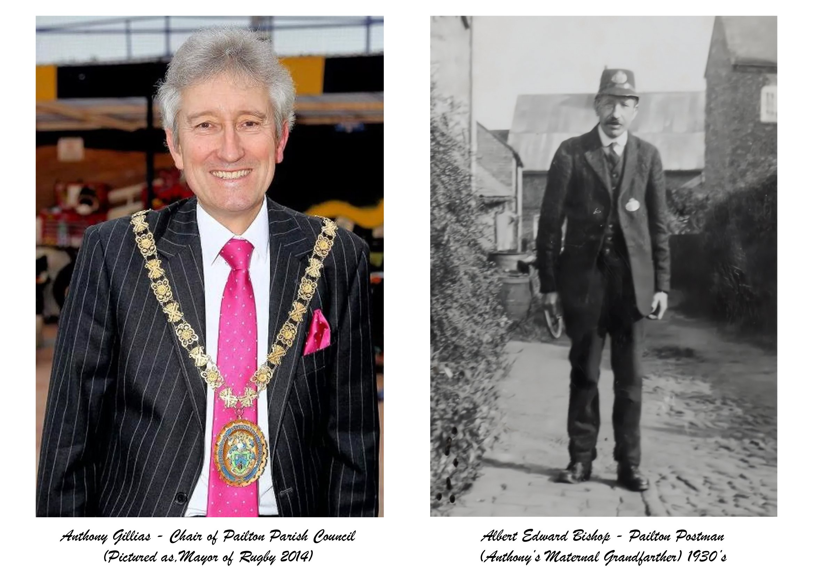
Delivery Phase – Collaboration and Sustainability
An Activity Consultant will be appointed, to design and establish several of the activity streams. However, many of the activities will be led by the PWLWG day to day, with contributions and training from the Activity Planning Consultant, Oral History trainer, Business Planning Consultants, and Evaluation Consultant. In addition to the PWLWG/CIC, volunteers will be recruited, as well as a Research Intern; these intern and volunteer roles will ensure that people are trained in new skills, benefitting both the individuals and the village. Some of the pub-related activities will be run by the pub management, once the White Lion has reopened and is up and running. This distribution ensures that activities are better embedded into village life, and are therefore more sustainable for the long term.

To further encourage skill development, and ensure sustainability and long term collaboration, a number of partnerships will be formed. Some partnerships will take the form of advice or training during activity development (e.g. Oral History Society) while others will be long term partnerships with organisations delivering activities together (e.g. Re-Engage). The partnerships include:
- Oral History Society
- Postal Museum
- County Records Office
- Pub History Society
- Oddfellows Society
- Re-Engage
- National Hospitality Academy
- Pailton Parish Hall

Delivery Phase – Activity Statement
The following table outlines the Activity Statement for the Delivery Phase:

Activity | Target Audience for Activity | Partner / Provider | Outcome | Resources | Costs |  | Budget Line | Timetable | Targets & measures of success | Method(s) of evaluation | Lead
History of White Lion Interpretation: £6,692
 | Local community | Local artist | Local history captured and preserved |  |  |  |  | Design: run up to completion of capital works | Display tells variety of stories: at least 3 | Final display | PWLWG & volunteers from the village
 | Visitors to pub |  | Local history shared with wider audience |  |  |  |  |  | Range of community members involved: range of ages and background | Volunteer participation data (number and demographic spread)
 |  |  | Additional reason for people to visit |  |  |  |  | Delivery: unveiled at launch celebration | Oddfellows artefacts preserved and displayed: at least 3 artefacts
 |  |  | Heritage will be identified and better explained
Pub: Create display of artefacts and photographs; using stories from the Memory Sharing Hubs, and including artefacts related to the Oddfellows Society. |  |  |  | Design input | Design input | 1800 | Cost of launch celebration
 |  |  |  |  | Materials | 1000
 |  |  |  |  | Document facsimiles | 792
 |  |  |  | Publicity | Publicity | 200
Pub: Recruit local/young artist to decorate the pub with traditional signage and quotes from Oral History interviews |  |  |  | Artist | Materials | 200
 |  |  |  |  | Time | 2250
Rooms: Name each room after a prominent local person / feature, with input from Memory Hubs. |  |  |  | Design input | Design input | 450
 |  |  |  |  | Printing
For further information and visuals, see Delivery Phase – Interpretation Plans |  |  |  | Volunteer time | Volunteer Expenses | 200 | Travel and expenses for volunteers
Launch celebration: £1,700
Celebration event held at completion of the capital works, to bring together key stakeholders and members of the local community, and to advertise the services that the White Lion offers in its new form. | Local community |  | Local community engaged and celebrated |  | Catering | 1500 | Costs of launch celebrations | Held: at completion of capital works | Range of community members involved: range of ages and background | Attendee data (number and demographic spread) | PWLWG & Project Managers
 | Project team, including volunteers |  | Increased awareness of project and now fully opened site |  | Publicity | 200 |  |  |  | Attendee feedback
 |  |  | A wider range of people will be involved in heritage | Volunteer time | Volunteer Expenses | 50 | Travel and expenses for volunteers |  |  | Potential bookings of facilities
 |  |  |  |  | Activity Consultant days | 2 | Activity Consultant
Memory Sharing Hubs: Meetings: £900
Events where locals share their memories of the White Lion and village, with each other and with the project team. | Local community |  | Opportunity for intergenerational activity |  | Hospitality (10 sessions) | 500 | Village memories and collection display project | Throughout capital works, utilising other local sites until the White Lion is accessible | Range of community members involved: range of backgrounds and previous levels of engagement with project | Attendee data (number and demographic spread) | Activity Consultant to set up, then PWLWG to run regularly
 |  |  | Locals feel more engaged with project |  | Venue hire (10 sessions) | 400 |  |  | Variety of stories shared | Attendee feedback
 |  |  | Local history captured and preserved | Volunteer time | Volunteer Expenses | 200 | Travel and expenses for volunteers
 |  |  | People will have greater wellbeing |  | Activity Consultant days | 5 | Activity Consultant
Memory Sharing Hubs: Oral History: £790
Although villagers are welcome to attend the hubs to socialise and share memories, they can also participate in slightly more formal sessions where their memories will be recorded. Volunteers will receive Oral History training, so they can conduct the interviews in a location and time that villagers are comfortable with. | Local community | Oral History Society | Opportunity for intergenerational activity | Resources | Recorder | 120 | Village memories and collection display project | Throughout capital works, utilising other local sites until the White Lion is accessible | Variety of stories shared: at least 5 interviews | Oral History interviews conducted | Oral History trainer
 |  |  | Locals feel more engaged with project |  | Laptop (for depositing and editing) | 500 |  |  | Stories safely stored: archived in 2 locations | Oral History interviews archived
 |  |  | People will have developed skills |  | Hard drive | 70 |  |  | Interviews used for at least 3 outputs: memory sharing hub outputs, pub interior design, online content, etc. | Oral History interviews shared
 |  |  | Heritage will be identified and better explained |  | Extras (SD cards, headphones, cables, etc.) | 100
 |  |  |  | Oral History trainer | Oral History training: £480/day, plus expenses | 1060 | Training for volunteers
 |  |  |  | Volunteer time | Volunteer Expenses | 200 | Travel and expenses for volunteers
 |  |  |  |  | Activity Consultant days | 2 | Activity Consultant
Memory Sharing Hubs: Output: £1,700
Using memories from the Hubs and Oral History, create resources, interpretation, or activities that tell the stories of Pailton in addition to the final display, and in advance of its completion. Outputs could include pamphlets, storytelling beer mats, sharing of oral history through podcasts, etc. (This is in addition to quote used in interior decoration of pub, listed above) | Local community |  | Opportunity for intergenerational activity | Printed resources | Resources | 800 | Village memories and collection display project | Throughout capital works, utilising other local sites until the White Lion is accessible; beginning once several Hub meetings have been held, to gather stories | Range of community members involved: range of backgrounds and previous levels of engagement with project | Attendee data (number and demographic spread) | Activity Consultant to set up, then PWLWG to run regularly
 | Visitors to pub and accommodation |  | Locals feel more engaged with project |  | Design input | 900 |  |  | Variety of stories recorded in resources: at least 3 forms (social media post, blog, leaflet, etc.) | Attendee feedback
 | Family history researchers |  | Heritage will be identified and better explained | Volunteer time | Volunteer Expenses | 50 | Travel and expenses for volunteers |  |  | Resources produced
 |  |  | A wider range of people will be involved in heritage |  | Activity Consultant time | 5 | Activity Consultant
Interactive Post Office Resources: £2,650
Celebrate the history of the Post Office in Pailton, through interactive resources and toys for children, sited in the pub. These will be created by local craftspeople, inspired by the stories unearthed by Research Volunteers and research at the Postal Museum. | Local community – families and adults | Postal Museum | Local history shared with wider audience | Site Visit | The Postal Museum visit (10 adults; 3 children) | 200 | Support for activity programmes | Design: in run up | Resources well used: by many families and visitors | Visitor data | Activity Consultant
 |  |  | Local children know more about the history of their area | Design and build time | Design input | 450 |  | Delivery: post completion (onsite) |  | Visitor feedback
 |  |  | Families visit the pub more, as there are interesting things for the children to play with |  | Resource creation (e.g. mini PO toys) | 2000
 |  |  | Heritage will be identified and better explained | Volunteer time | (Volunteer Expenses: £400 for Museum visit; £200 for events) | 600 | Travel and expenses for volunteers
 |  |  |  |  | Activity Consultant time | 3 | Activity Consultant
Volunteer Research: £884
Volunteers conducting research into the history of Pailton and the White Lion pub, as well as related themes such as Oddfellow Society meetings, nearby turnpike roads, Post Office within the pub, etc. This research will contribute to resources and activities throughout the project, including the lecture series. The research will be done both onsite (e.g. at archives) and virtually (e.g. using resources hosted online such as Ancestry) allowing more people to get involved, including those who are less able to leave their homes, e.g. carers, people with chronic conditions. Findings will be shared online, through pub interpretation, and at events for locals and schoolchildren. There are already many villagers interested in volunteering for this role, but the Activity Consultant will also openly recruit, to extend the opportunity more broadly. | Local community - of all ages and backgrounds | County Records Office | Heritage will be identified and better explained | Onsite Research | Trip to County Records Office | 150 | Training for volunteers | From outset of project (once Research Intern and Activity Consultant appointed) | Range of stories uncovered, e.g. Oddfellows, individual stories, pub history; at least 10 stories / finds | Research outputs | Activity Consultant & Research Intern
 | School children | Pub History Society | A wider range of people will be involved in heritage |  | Laptop | (Use OH laptop) |  |  | Range of community members involved: range of backgrounds and previous levels of engagement with project; at least 10 volunteers | Attendee data (number and demographic spread)
 | Students | Oddfellows Society | People will have developed skills |  | Prints of materials | 100 |  |  | Range of sources / sites consulted; at least 3 places visited / consulted | Volunteer feedback
 |  |  | People will have learnt about heritage, leading to change in ideas and actions | Online Research | Online subscriptions: Ancestry; Oddfellows Archive; British Newspaper Archive | 235.39
 |  |  |  | Society Subscriptions | Pub History Society | 64
 |  |  |  | Training | Research training | 200
 |  |  |  |  | Transcription / palaeography | 135
 |  |  |  | Volunteer time | Volunteer Expenses | 200 | Travel and expenses for volunteers
 |  |  |  |  | Activity Consultant time | 5 | Activity Consultant
Research Intern: £4,450
Internship offered for entry level researcher, suiting those starting or changing to careers in heritage or journalism. The Research Intern will coordinate the Research Volunteers. They will also be responsible for identifying the key stories, quotes, or photographs for interpretation within the pub and on the website. Depending on their skills and ambitions, they may then create content for the website and/or write interpretation for within the pub. They will also deliver events for locals and at least one session in the local primary school, sharing some of the findings in an exciting and age appropriate way. Training budget is included, to offer training for the intern; the specifics will be decided between the Intern and the Activity Coordinator, tailored to meet the needs of the Intern. | Young person / career changer looking for experience | Primary School | A wider range of people will be involved in heritage | Reimbursement | Reimbursement for hours | 3850 | Training for Staff | From outset of project (once Activity Consultant appointed) for approx. 12 months; probably September to September, suiting the academic year | Research Intern develops new skills | Feedback | Activity Consultant
 | School children |  | People will have developed skills | Training | Training for Intern (to be determined by Intern) | 600 |  |  |  | Next steps taken by Research Intern; e.g. new job, course, etc.
 | Researchers |  | People will have learnt about heritage, leading to change in ideas and actions |  | Activity Consultant time | 4 | Activity Consultant |  | Research Intern shares stories with local people and schoolchildren | At least one event for locals and at least one session in the primary school
What made Pailton?: £1,950
Lecture series looking at the history of Pailton as a way of exploring the history of social enterprise and charity in Britain. Lectures will be recorded and shared online. They will cover nationally interesting topics, explored in more detail at a local level. Topics include: 18th C: Oddfellow Society; 18th C: Turnpike roads; 19th C: Post Office network; 20th C: 1756 Acres social history / Oral History; 21st C: How can we save our Pubs? | Local community | Oddfellows Society | Local history shared with wider audience | Volunteer time | Speaker costs | 500 | Village memories and collection display project | Both post completion (onsite) and during capital works, to maintain interest from community | Activities well attended: at least 100 attendees (online and in-person combined) | Attendee data (number and demographic spread) | Activity Consultant
 | Oddfellows Society members | Pub History Society | Good relationship with Oddfellows Society and its members | Speaker | Speaker expenses | 250 |  |  | Research gained interest: at least 2 publications | Attendee feedback
 | Social Historians | Postal Museum | Local history captured and preserved |  | Recording set up / sharing | 500
 | Family history researchers |  | Heritage will be identified and better explained |  | Output / resource | 700
 | Oral Historians |  | People will have learnt about heritage, leading to change in ideas and actions |  | Volunteer Expenses | 100 | Travel and expenses for volunteers
 | Other pubs / community groups, looking to learn best practice |  |  |  | Activity Consultant time | 6 | Activity Consultant
Family fun activities: £1,200
Host a range of family activities, relevant to village life in Pailton; for example, hosting a stall at the local summer fete, or putting on a Christmas quiz. | Local community – specifically families |  | Locals are better engaged with the project | Publicity | Publicity | 200 | Support for activity programmes | Ongoing from completion of capital works | Activities well attended: at least 300 visitors (across all activities) | Attendee data | Activity Consultant & PWLWG
 |  |  | Additional reason for people to visit | Resources for activities | Resources | 1000 |  |  |  | Attendee feedback
 |  |  | The local area will be a better place to live, work or visit | Volunteer time | Volunteer expenses | 200 | Travel and expenses for volunteers
 |  |  |  |  | Activity Consultant time | 5 | Activity Consultant
Local Producer Markets: £4,900
Host farmers markets and craft markets, to benefit local producers and local residents, and bring more people into Pailton. Stalls would be offered to upcoming producers at a reduced rate for their first market, to encourage new businesses. All stalls would be hired to producers based in the local area. Markets would be themed, to form an annual calendar; e.g. farmers market in Spring, family market in Summer, craft market in Autumn, Christmas market in Winter. | Local community – as visitors and sellers |  | Additional reason for people to visit | Market | Stall hire | 3000 | Support for activity programmes | Initial markets held during capital works (when site closed at weekends) | Local businesses choosing to attend: at least 10 different businesses | Attendee data (number and demographic spread) | Pub Management, with Business Planning input
 | Tourists |  | Opportunity for income generation for local people | Market | Branding and decorations for each theme | 1600 |  |  | Visitors choosing to visit, from further afield than the village | Feedback from vendors
 |  |  | People can learn more about where their food comes from | Publicity | Publicity | 300 |  |  | Local businesses gaining ongoing business | Booking data; particularly how many vendors re-book to attend markets
 |  |  | The local area will be a better place to live, work or visit | Volunteer time | Volunteer expenses | 60 | Travel and expenses for volunteers | Ongoing from completion of capital works
 |  |  | The local economy will be boosted |  | Business Planner time | N/A | Included in Professional Fees: Business Planner
Co-working space: £200
Provide co-working provision for local professionals and students to use, bringing benefit to the local community - reducing energy costs for households, bringing together different, members of the community, combating loneliness – and generating income for the pub. Following community consultations, this will take the form of offers (e.g. loyalty cards for regular co-workers) and marketing, rather than a dedicated physical space. | Local community – specifically those of working age, and students |  | Additional reason for people to visit | Publicity | Publicity | 200 | Support for activity programmes | Ongoing from completion of capital works | Workers choosing to use pub as a co-working space: at least 3 a week | Feedback from visitors | Pub Management, with Business Planning input
 |  |  | Opportunity to combat loneliness amongst home-workers by providing sense of community |  | Business Planner time | N/A | Included in Professional Fees: Business Planner |  | Positive impact on attendees and local community to tackle loneliness
 |  |  | More efficient use of energy, saving energy costs and reducing emissions
 |  |  | The local area will be a better place to live, work or visit
Host community groups: £500
Host meetings and lunches for community groups, such as the cycling club or gardening group. Events will also be particularly focusing on including vulnerable people such as older people; for example, groups may include: Re-engage tea parties. | Local community | Re-Engage | Additional reason for people to visit | Hospitality | Hospitality (for charity groups) | 300 | Support for activity programmes (£5,000) | Ongoing from completion of capital works | Positive impact on attendees and local community to tackle loneliness | Feedback from participants | Pub Management
 |  |  | Opportunity to combat loneliness by providing sense of community | Publicity | Two Re-engage tea parties | 200 |  |  | Groups choosing to use site as a venue: at least 3 a month | Booking data
 |  |  | People will have greater wellbeing | Volunteer time | Volunteer expenses | 100 | Travel and expenses for volunteers
Traditional pub game tournaments: £2,500
Coordinate competitions for traditional pub games, such as darts, shuffleboard, and bagatelle. There will be accessible and family friendly games, such as dominos. The main focus will be the re-entry into the local skittle league, building on the traditions identified in the CMP, and the strong history of table skittles in Warwickshire. The hope is to create a full league, in time. In addition, there will be less common games, such as ‘Spoof’ or ‘Ring the Bull’, sharing the history of pub games with new audiences. Some will be sited outside in summer, like 'Aunt Sally'. | Local community |  | Additional reason for people to visit | Publicity | Publicity | 200 | Support for activity programmes | Ongoing from completion of capital works | Range of pub games played: at least three | Visitor numbers | Pub Management, with support from PWLWG and Activity Consultant
 | National pub game community |  | Pub history shared with wider audience | Resources | Table skittles | 1000 |  |  | Competitions attract visitors: at least 25 at each competition, at least 6 times a year | Competition records
 |  |  |  |  | Other pub games | 1000
 |  |  | Pub game traditions maintained for future generations |  | Prizes | 300
 |  |  | A wider range of people will be involved in heritage | Volunteer time | Volunteer expenses | 120 | Travel and expenses for volunteers
 |  |  |  |  | Activity Consultant time | 2 | Activity Consultant
White Lion Website Design: £20,000
Develop a website for the White Lion pub, serving two purposes: sharing the history of the White Lion, including oral history snippets, findings from research, and photographs; and providing information about booking a room or visiting the pub, with information about rooms, opening hours, etc. It will follow the example of other similar websites that do this well, e.g. The Old Kings Head in Boston. The consultants recruited to design the website will also train up key staff and CIC members in how to update the website, to ensure that it doesn't become obsolete, and is updated regularly. | Local community |  | Local history captured and preserved | Design | Website design | 20000 | Digital Outputs | Begins during research and construction phase |  |  | Digital Consultant
 | New visitors to the pub |  | Local history shared with wider audience | Maintenance | Training for staff and CIC members | N/A | Included within Brief | Launched 3 months before opening, with opening details
 | Researchers |  | A wider range of people will be involved in heritage |  |  |  |  | Updates ongoing
 | People interested in local history |  | Heritage will be identified and better explained
Heritage Open Days: £200
Participate in Heritage Open Days by opening up the site for visitors, and putting on extra events or activities that share the history of the pub and advertise its current community offer. | Local community |  | Additional reason for people to visit | HOD branded resources | HOD branded resources (provided by HOD) | 0 | Support for activity programmes | Ongoing from completion of capital works | Participate annually | Attendee data (number and demographic spread) | PWLWG, with support from Activity Consultant
 | Tourists |  | Local history shared with wider audience | Resources for activities | Resources for activities | 200 |  |  | Attract wide range of visitors | Attendee feedback
 |  |  | Heritage will be identified and better explained | Volunteer time | Volunteer expenses | 100 | Travel and expenses for volunteers
 |  |  | A wider range of people will be involved in heritage |  | Activity Consultant time | 3 | Activity Consultant
National Lottery Open Week: £300
Host special tours and events for lottery players, putting on extra events or activities that share the history of the pub and advertise its current community offer. | Local community |  | Thanks lottery players for their contribution | Lottery/NLHF branded resources | Lottery / NLHF branded resources | 100 | Support for activity programmes | Ongoing from completion of capital works | Participate annually | Attendee data (number and demographic spread) | PWLWG, with support from Activity Consultant
 | Tourists |  | A wider range of people will be involved in heritage | Resources for activities | Resources for activities | 200 |  |  | Attract wide range of visitors | Attendee feedback
 |  |  | Heritage will be identified and better explained | Volunteer time | Volunteer expenses | 100 | Travel and expenses for volunteers
 | Lottery players |  | Local history shared with wider audience |  | Activity Consultant time | 3 | Activity Consultant
Community 'Gardens': £2,700
Create 'gardens' for community use, providing an opportunity for villagers to gain skills, from gardeners and from each other. These 'gardens' may take the form of raised beds or plant pots, but will be accessible (e.g. at suitable height for gardeners who are wheelchair users or have limited mobility). A team of volunteers will coordinate maintenance of the garden, encouraging a wide range of participants, particularly focusing on offering community to people struggling with loneliness. Work will be done with villagers and local children to share learning about food sourcing, and volunteers will attend training to facilitate this (e.g. LEAF seminars). Produce grown will then be used in the pub kitchens. In addition, there will a specific Cocktail Garden, growing herbs and garnishes to used in cocktails and mocktails in the pub. | Local community |  | People learn how to garden and grow their own food | Resources to maintain beds: tools, plants, etc. | Raised beds | 600 | Training for volunteers | Installed: in final stages of capital works | Beds produced | Completed beds | Activity Consultant to set up, villagers to run
 |  |  | Opportunity for intergenerational activity |  | Tools | 300 |  | Volunteer training begins: at completion | Beds used and maintained | Participation data and feedback
 |  |  | Opportunity to combat loneliness by providing sense of community |  | Plants | 600 |  | Maintenance: ongoing | Volunteers trained: at least 10 volunteers participate | Feedback from visitors to garden
 |  |  | People will have developed skills |  | Resources to maintain gardens | 1200 |  |  | Gardens produce produce! | Produce from gardens
 |  |  | People will have greater wellbeing | Volunteer and staff time, to supervise | Volunteer expenses | 200 | Travel and expenses for volunteers
 |  |  | The local area will be a better place to live, work or visit |  | Activity Consultant time | 3 | Activity Consultant
Evaluation training: N/A
Training delivered by the Evaluation Consultant, to provide support and training for volunteers, staff, trustees in evaluation methods, and make sure the focus on desired outcomes and ambitions are maintained. | Staff and volunteers |  | People will have developed skills | Evaluation Consultant time | Evaluation Consultant time | N/A | Evaluation | Throughout capital works | Staff and volunteers trained: at least 6 volunteers, from a range of roles | Participation data | Evaluation Consultant
 |  |  |  | Staff time |  |  |  |  |  | Participation feedback, including impact several months on
 |  |  |  | Hospitality | Catering | 200 | Travel and expenses for volunteers
 |  |  |  | Volunteer time | Volunteer expenses | 400
Accessibility training: £1,000
Training delivered by accessibility experts, to ensure that staff are equipped to provide an equal and inclusive experience for all customers and visitors. This will build on the improvement to the accessibility of the building as part of the capital works. | Local community |  | People will have developed skills | Trainers | Accessibility Trainer time | 900 | Training for staff | Staff training begins: in final stages of capital works, to learn how new site works, ready for opening | Staff trained: at least 5 members of staff | Participation data | Accessibility Trainer
 | Visitors to pub and accommodation |  | Customers and visitors have a more positive experience | Staff time | Resources | 100 |  |  | Visitor feedback positive | Participation feedback
 |  |  | Reputational benefit; pub is known for being welcoming to all | Resources |  |  |  |  |  | Visitor feedback
 |  |  | People will have greater wellbeing
Social Media training: £975
Social Media training for the Manager and one or two additional members of staff, to run the social media channels for the pub. Having staff equipped to create the content in-house will allow staff to share food, specials, offers, quotes from visitors, etc., and bring the channels to life. They will also be able to refer to heritage stories, artefacts, or oral history recordings, in line with online initiatives. Because social media and online reputation is vital in creating a popular pub, a basic social media awareness course - run by the National Hospitality Academy - will be part of the initiation for all FOH and kitchen staff. | Staff and volunteers | National Hospitality Academy | People will have developed skills | Social Media training | Full social media training for three members of staff; e.g. Manager and two additional staff members | 600 | Training for staff | Training begins once Digital Consultant appointed | Staff trained: at least 5 members of staff, in addition to 3 key members | Participation data | External trainer / Digital Consultant
 |  |  | Reputation of the pub will be strong |  | Short online course for all FOH and kitchen staff and the CIC | 375 |  | Short online course is offered to staff as they start, before opening | Content produced; at least 3 posts a month | Participation feedback
 |  |  |  | Staff time |  |  |  |  | Content reaches new audiences | Engagement data
Operational staffing role: £30,000 |  |  |  |  | Business Planner time |  | Operational staffing (£30,000) | ‘As we get closer to opening, we will recruit core operational staff.’ | Note: Have requested actual estimate from Mark Hobbs and DCA |  | PWLWG, with Business Planning input

Delivery Phase – Budget Summary
Budget Line | Activity | Anticipated Costs | Original Budget
New Staff Costs
Operational Staffing | Contribution towards operating revenue Year 1 – 2 (see Business Plan for details) | £30,000
 | Total | £30,000 | £30,000
Training for staff
For local people in delivery phase works and activities | Evaluation training | N/A
 | Accessibility training | £1,000
 | Social Media training | £975
 | Research Intern | £4,450
 | Total | £6,425 | £5,000
Training for volunteers
Training for volunteers | Memory Sharing Hubs: Oral History - Oral History Training | £1,060
 | Community 'Gardens' | £2,700
 | Volunteer Research | £884
 | Total | £4,644 | £3,000
Travel and expenses for volunteers
Travel and expenses for volunteers | Expenses for volunteers assisting with the listed activities | £3,080 | £3,000
 | Total | £3,080 | £3,000
Equipment and materials (activity)
Costs of launch celebrations | History of White Lion Interpretation | £6,692
 | Launch celebration | £1,700
 | Total | £8,392 | £5,000
Support for activity programmes | Family fun activities | £1,200
 | Local Producer Markets | £4,900
 | Co-working space | £200
 | Host community groups | £500
 | Traditional pub game tournaments | £2,500
 | Heritage Open Days | £200
 | National Lottery Open Week | £300
 | Interactive Post Office Resources, e.g. toys | £2,650
 | White Lion Website Design | N/A
 | Total | £12,450 | £5,000
Village memories and collection display project | Memory Sharing Hubs: Meetings | £900
 | Memory Sharing Hubs: Oral History - Conducting Interviews | £790
 | Memory Sharing Hubs: Output | £1,700
 | What made Pailton? (snappier title TBC!) | £1,950
 | Total | £5,340 | £4,000
 | Total | £26,182 | £14,000
Professional fees relating to any of the above (activity)
Activity planning and coordination: (at £450/day) | Activity Consultant: day allowance | 48
 | Total | £21,600 | £10,000
Total Activity Costs | Total | £91,931 | £65,000
 | Ratio to capital costs | 3.36%

Delivery Phase – Interpretation Plans
As the White Lion will be an operational pub, the heritage stories will be told within the pub environment; this means interpretation must fit into the pub design, sharing stories in an informal way. It is also vital that interpretation does not take up floor space, in order to maximise the number of covers in the pub. Below are examples from the Review of Best Practice, ideas from other pubs and sites sharing heritage in a creative yet practical way, which may inspire design choices.
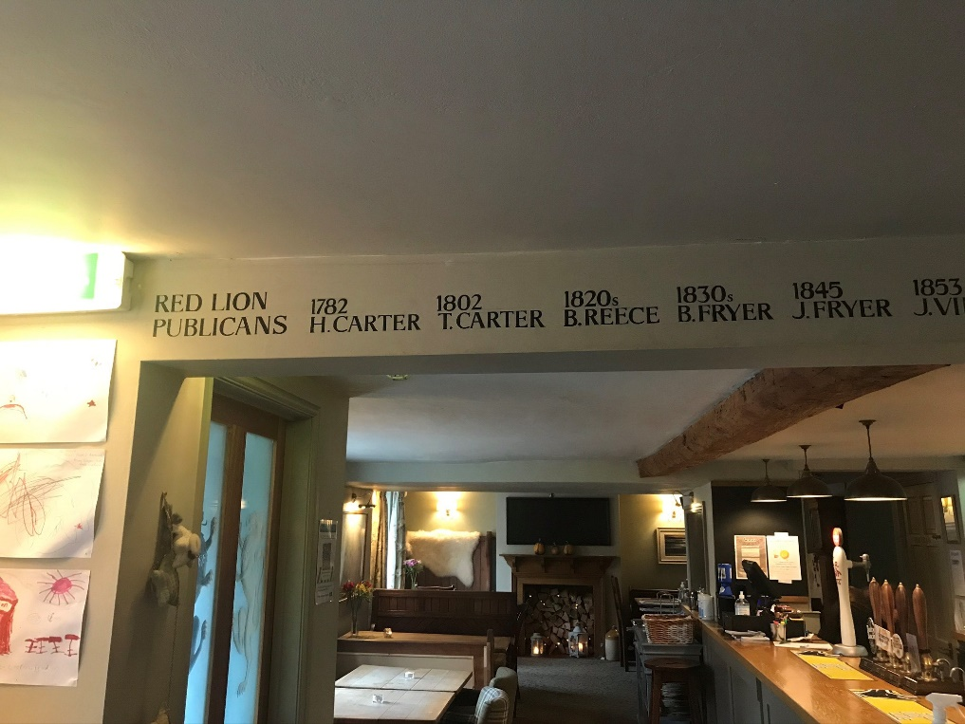
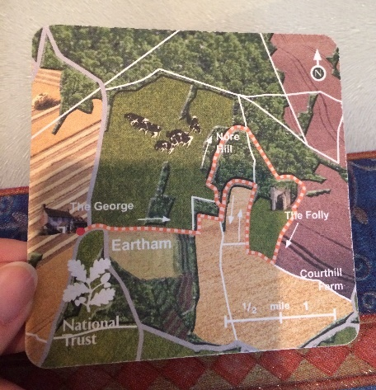
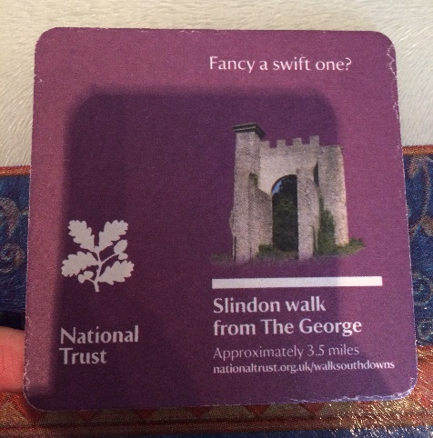
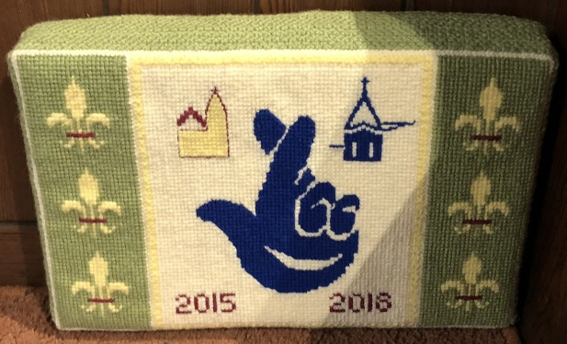
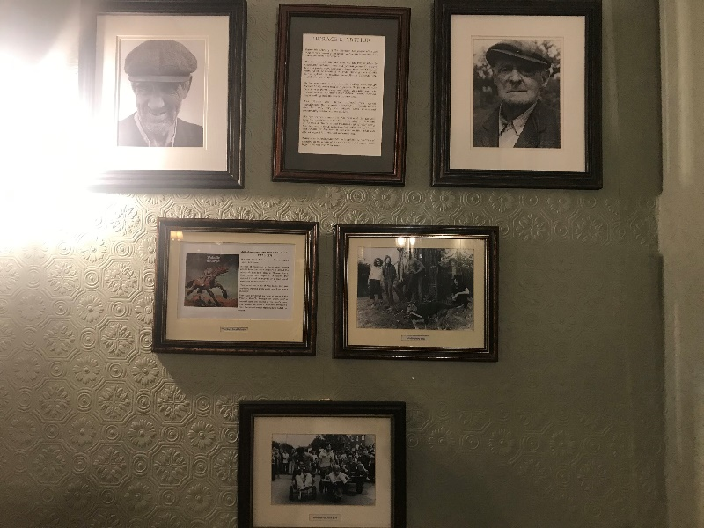
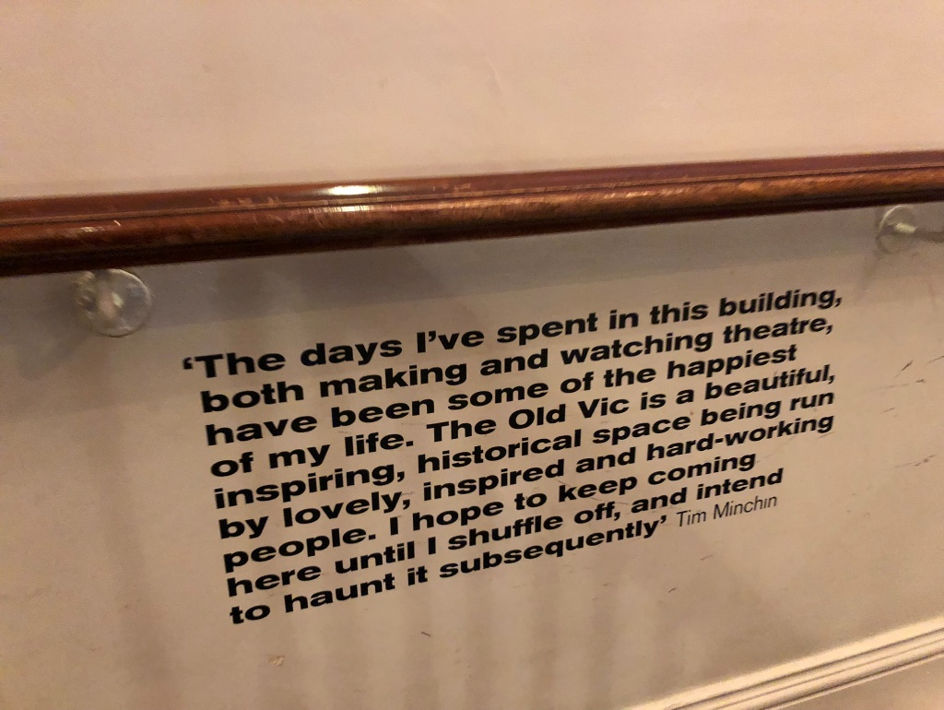
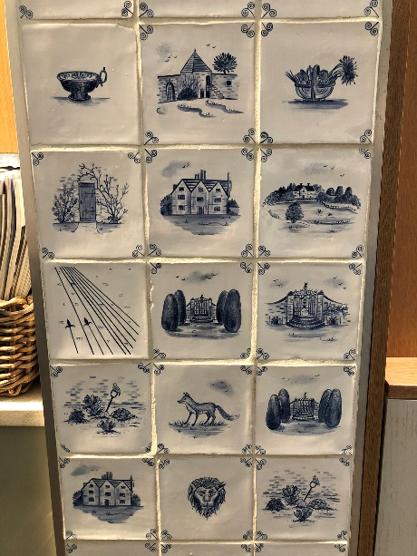
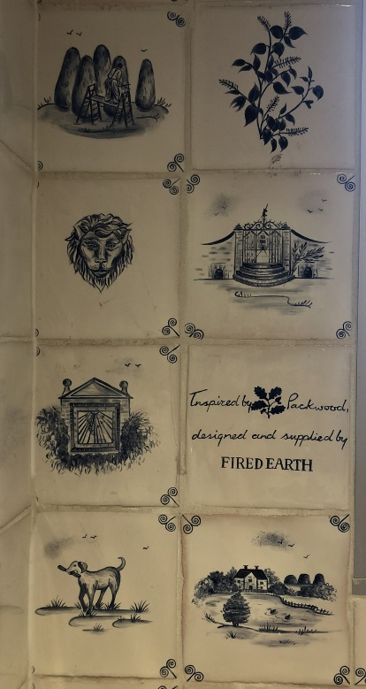
Name and timeline of past landlords along the bar
Red Lion, Arlington
Beer mats that tell drinkers more about the pub and area
The George, Slindon
Cushions used to thank funders
Edale Parish Church
Photographs of past residents and events
Red Lion, Arlington
Memories and quotes on the walls
Old Vic Theatre
Tiles painted with images of locality
Packwood House

Further Evaluation is available in the Evaluation Framework and Emerging Findings document.
https://www.ohs.org.uk/training/tailored-training/
https://www.postalmuseum.org/event/sorted-the-postal-play-space/
The Intern will be paid Living Wage Foundation recommended wage; the rate included is as of October 2023, but will be revised at Delivery Phase to ensure that it meets LWF recommendations.
https://www.reengage.org.uk/volunteer/new-volunteers/do-you-want-to-be-a-change-maker-in-your-community/

